
Business Risk Matrix Template

Risk ID | Risk Title /  Risk Description | Risk Category | Likelihood (1–5) | Impact (1–5) | Risk Score | Risk Level | Risk Drivers / Root Cause | Potential Business Consequences | Existing Controls | Control Effectiveness | Mitigation Actions | Action Owner | Target Completion Date | Status | Residual Likelihood | Residual Impact | Residual Risk Score
 |  | Operational | 1 | 2 | 2 | Low |  |  |  | Effective | Planned |  |  | Open | 1 | 2 | 2
 |  | Financial | 2 | 3 | 6 | Medium |  |  |  | Needs Improvement | In Progress |  |  | Monitoring | 2 | 3 | 6
 |  | Strategic | 3 | 4 | 12 | High |  |  |  | Ineffective |  |  |  | Mitigated | 3 | 4 | 12
 |  | Compliance | 4 | 5 | 20 | Critical |  |  |  |  |  |  |  | Closed | 4 | 5 | 20
 |  | Reputational | 5 | 1 | 5 | Medium
 |  | IT

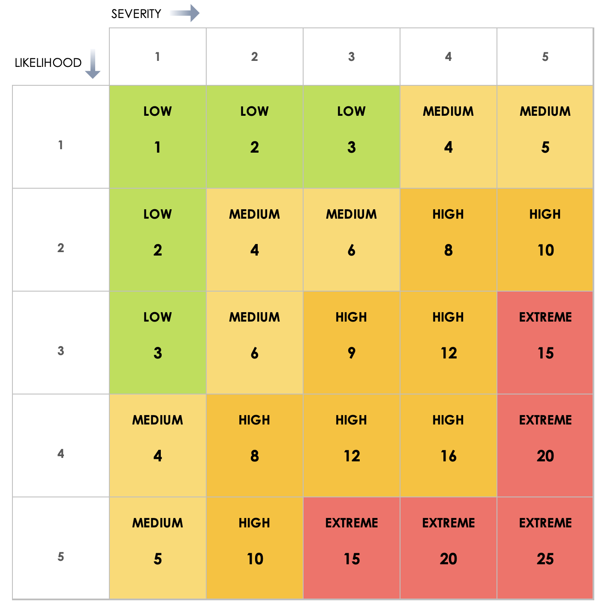

DISCLAIMER

Any articles, templates, or information provided by Smartsheet on the website are for reference only. While we strive to keep the information up to date and correct, we make no representations or warranties of any kind, express or implied, about the completeness, accuracy, reliability, suitability, or availability with respect to the website or the information, articles, templates, or related graphics contained on the website. Any reliance you place on such information is therefore strictly at your own risk.

